University Of Engineering and Technology, Lahore
Computer Engineering Department

Course Name: Programming Fundamentals | Course Code: CMPE-112L
Assignment Type:Lab tasks | Dated: 07-06-2026
Semester: 1st | Session: Spring
Lab/Project/Assignment #: 15 | CLOs to be covered: CLO 3
Lab Title: Qt Designer | Teacher Name: Hafiz Muhammad Mubashar
Lab Evaluation:

CLO1 | Apply appropriate programming techniques to create executable programs to solve well defined problems
 | Level1 | Level2 | Level3 | Level4 | Level5 | Level6
(5)
Total |  |  |  |  |  | /5
Rubrics for Current Lab Evaluation
Scale | Marks | Level | Rubric
Excellent | 5 | L1 | Submitted all lab tasks, BONUS task, have good understanding.
Very Good | 4 | L2 | Submitted the lab tasks but have good understanding
Good | 3 | L3 | Submitted the lab tasks but have weak understanding.
Basic | 2 | L4 | Submitted the lab tasks but have no understanding.
Barely Acceptable | 1 | L5 | Submitted only one lab task.
Not Acceptable | 0 | L6 | Did not attempt
LAB No 15
Lab Goals/Objectives:
This lab is basically designed for students to get in touch with Qt designer. And how to use its different tools. How to import .ui files from it. Which we can merge with our code later. This is a very simple and powerful tool. We can complete our difficult asks with it within few hours. It is easy to use.
Equipment Required:
A qt designer, Computer ro Laptop and a user.

Theory:
It will help us to create GUIs.

Lab Work:

Task 1: Create a login page.

Result:
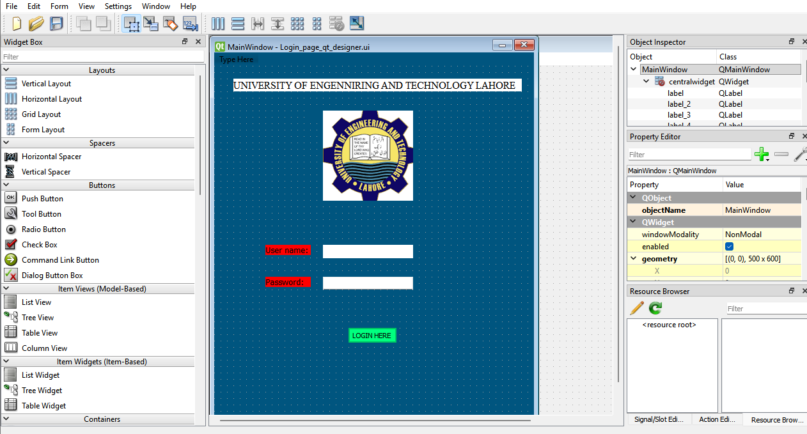

Conclusion:
We have created a login page with the help of qt designer and we used labels, tags and push buttons and imported a picture also.

